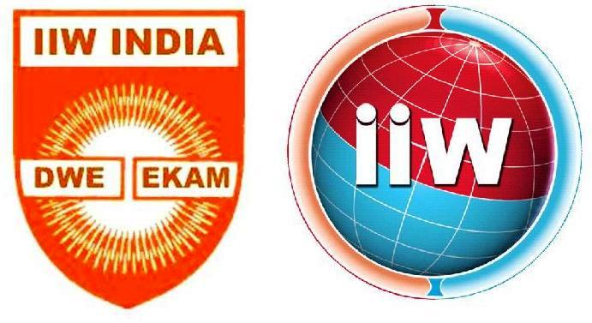

Certificate No: 35/3
ANB-IND
The Indian Institute of Welding-ANB
Authorised National Body of the International Institute of Welding in India
IIW-India House, Plot: 38Geetanjali Park Main Road
200, Kalikapur Road, P.O.Mukandapur,Kolkata – 700 099
Tel: +91 33 4006 1837, E-mail:anb@iiwindia.com, Web: http://www.iiwindia.com

Preliminary Information FORM to be filled by the Applicant

for Eligibility Determination IIW-(International) Qualification

(Before submission of formal Application FORM along with Fees as applicable)

- FULL NAME: …………………………………………………………………………………………
(In CAPITAL LETTERS WITH CORRECT SPELLING)

- Place of Birth& Date of Birth: Place:…………………………….DOB ………………………

- Name of Father/ Mother……………………………………………………………………………

- PostalAddress: ……………………………………………………………………………………… …………………………………………………………………………………………………………

- Contact Mobile Nos.:………………......
e-mail:…………………............ Skype………………………
- For Overseas Applicants
  - Address in India if available ……………………………………………………………………..
  - Contact person &Tel number in India if available.………………………….…….................
- Interested to Qualify as:(please √ or highlight any one or more after checking our Brochure and visit to our website link:http://iiwindia.com/personnel-qualification-certification/
  - INTERNATIONAL WELDING COORDINATION PERSONNEL
IWE
IWT
IWS
IWP
ITW
  - INTERNATIONAL WELDER: IFW IPW
  - Welding Processes:
MIG/MAG
TIG
MMA
- Admission to ATB for Standard Route or by Alternative Route/Transition Arrangement
- Academic Qualifications (from Class X onwards in India/overseas)
S. No. | Examination Passed | Board / Institute / University | Specialisation if any | Course duration (Mention if by distance mode) | Year of Passing
1
2
3
4
5
6
- Details of other Professional Examinations Passed or training received inWelding and related subjects and skills.
S. No. | Examination Passed  Training received | Organisation/ Institution | Specialisation | Course duration (Mention if by distance mode) | Year of Passing
1
2
3
4
5
6

- Details of Employment with current on top (chronologically in descending Order)
S. No. | Name of Employer  (Country of posting) | Status / Position | Job responsibility & function | Duration: dates
 |  |  |  | From | To | Months
1
2
3
4
5
6

- Core Experience (please √ any one or more based on your own assessment)
QA
Construction
Welded Fabrication
Production & Manufacturing
Product Marketing & Services
R & D
Training & Education

- I confirm that the information provided above are complete &correct and I shall submit Formal Application along with all supporting documents & application Fees. I understand that any communication from IIW-India ANB, based on the information provided does not confirm eligibility but only facilitates the application to be placed before the IIW India-ANB Assessment Committee regarding my eligibility following applicable IIW-IAB Rules & Guidelines which is final and binding on me.

Place:

Date:
Signature of Candidate
- - - - - - - - - - - - - - - - - - - - - - - - - - - - - - - - - - - - - - - - - - - - - - - - - - - - - - - - - - - - - - - - - - - - - - - -

FOR OFFICE USE ONLY

Comment after preliminary check for further action:

